Greg Hallahan
www.greghallahanart.com
greghallahan00@gmail.com

Image list on the last page.

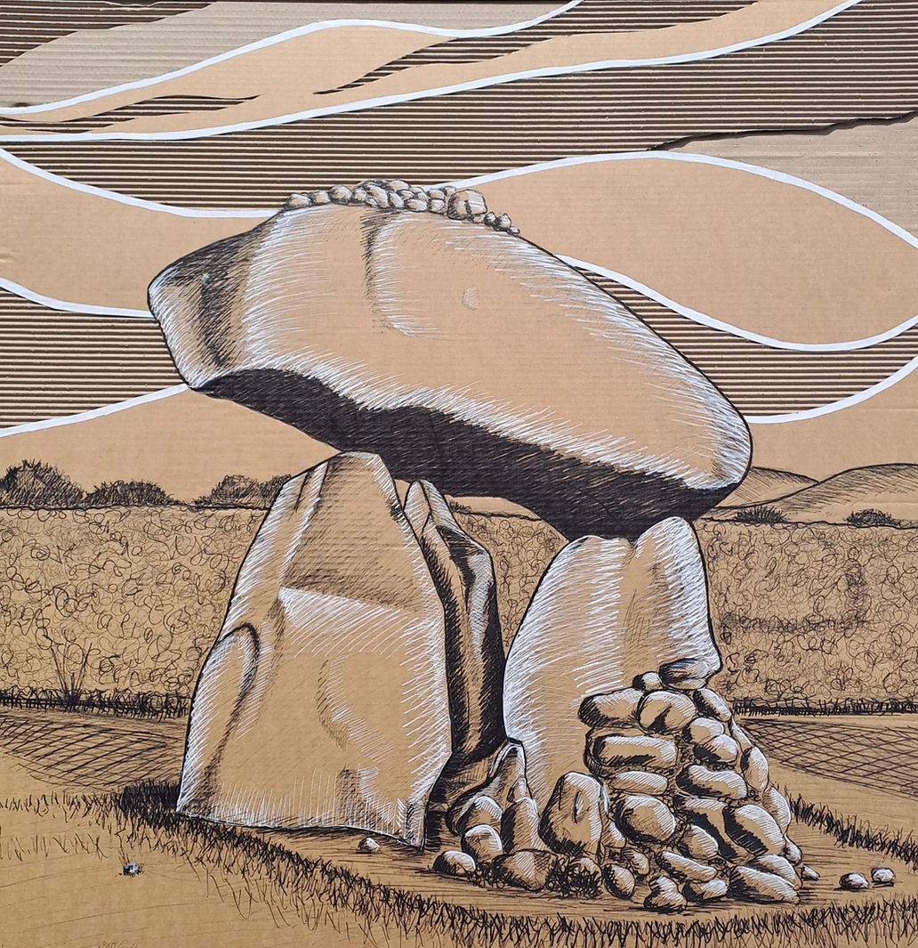
“Unknown, Unheard, Unseen”
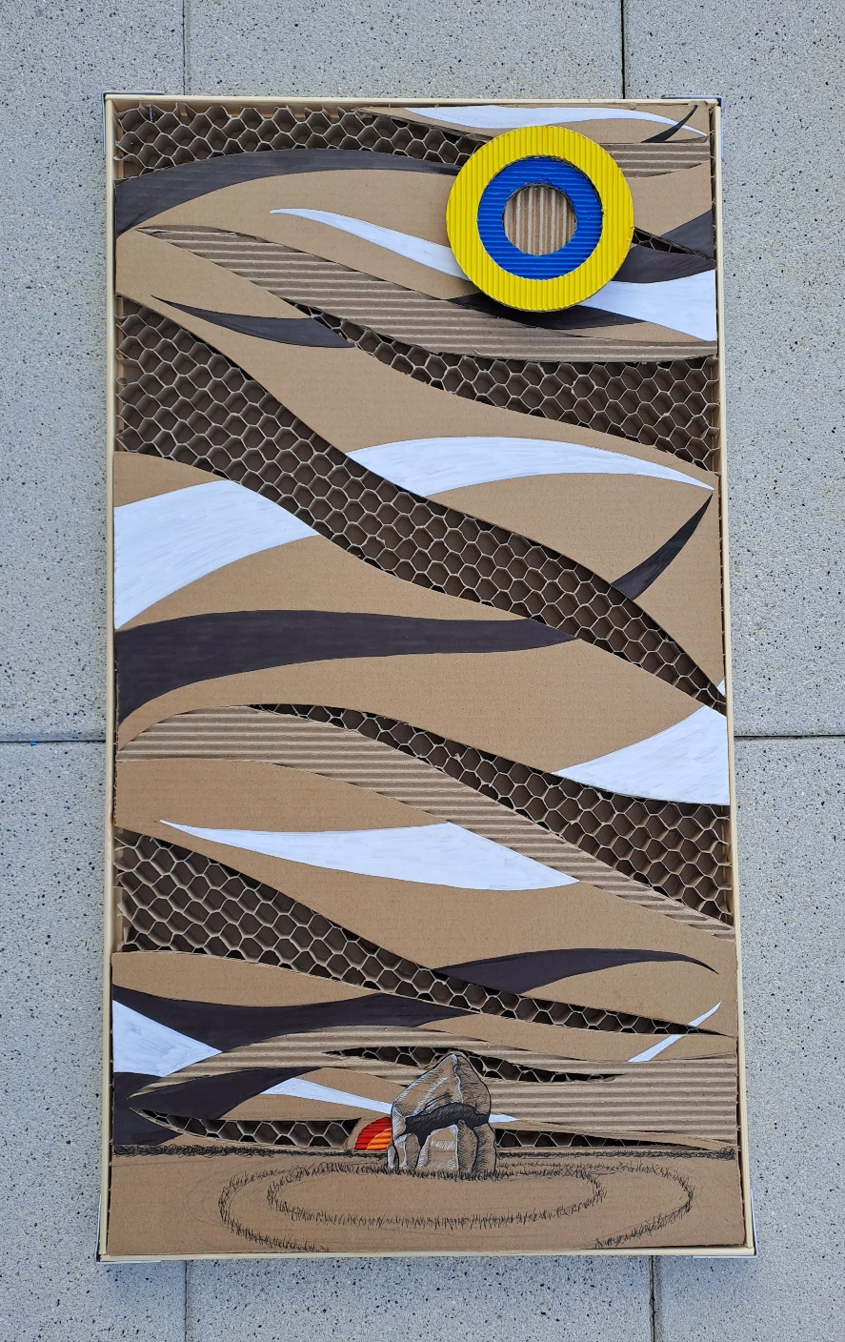
“Somewhere Among the Clouds Above”

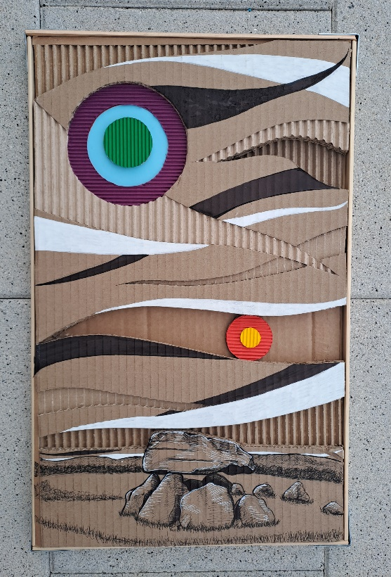
“Knotted Cascade”

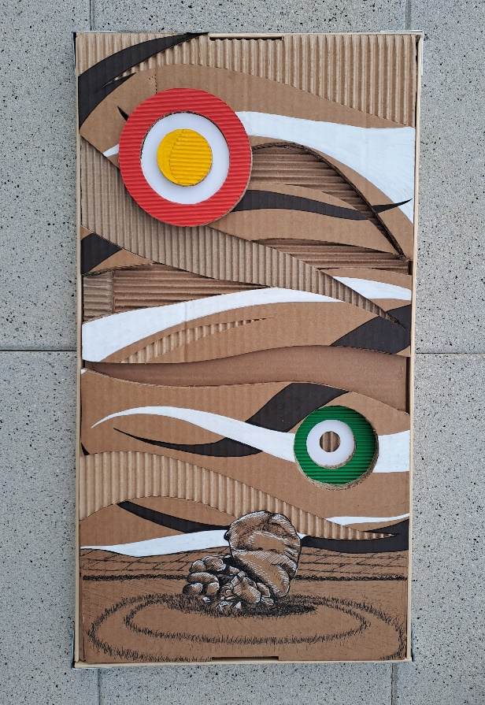
“Butterflies of Vertigo”

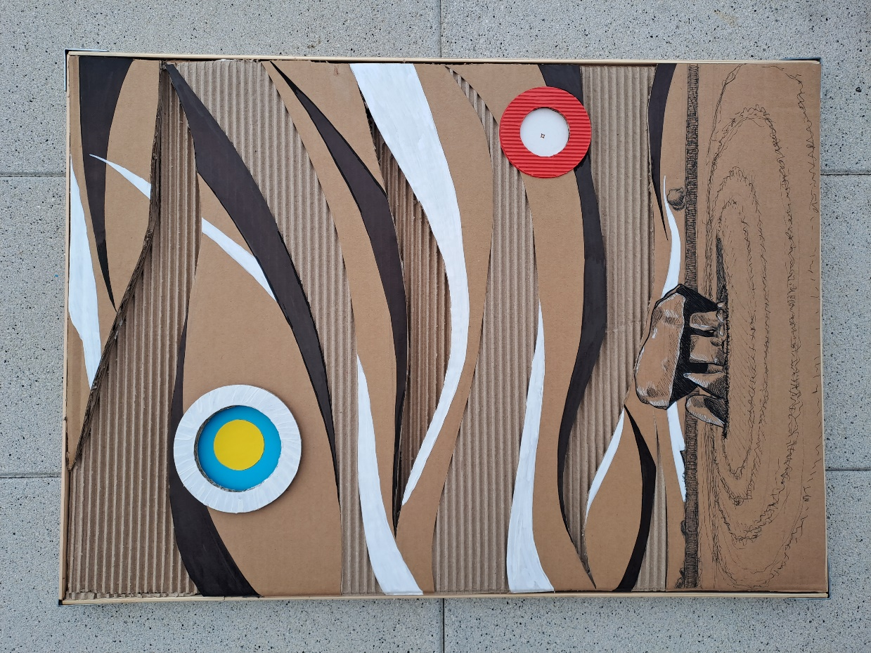
“Stencils of the Moon”

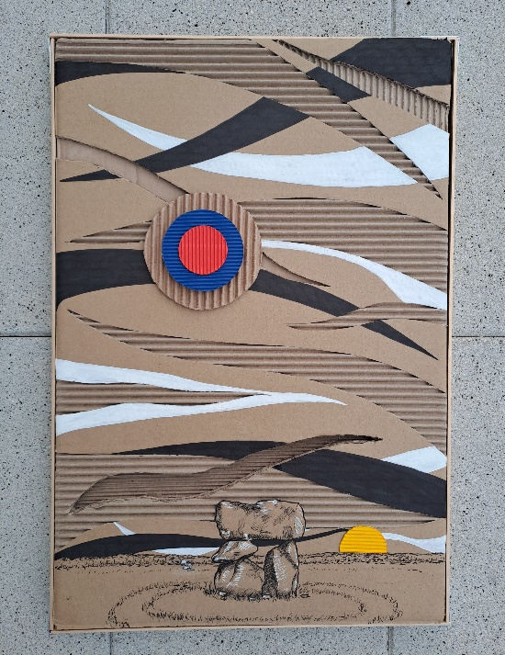
“Beauty, It Curves”

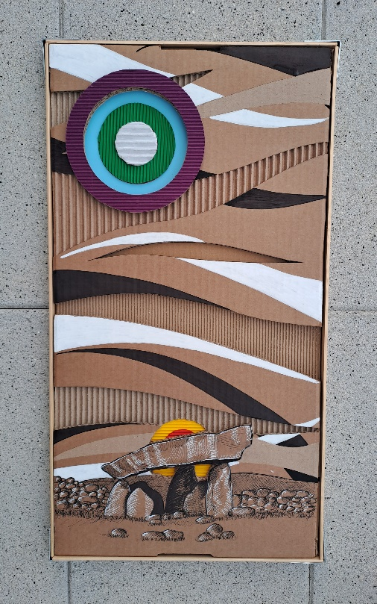
“Embossed Aperture”

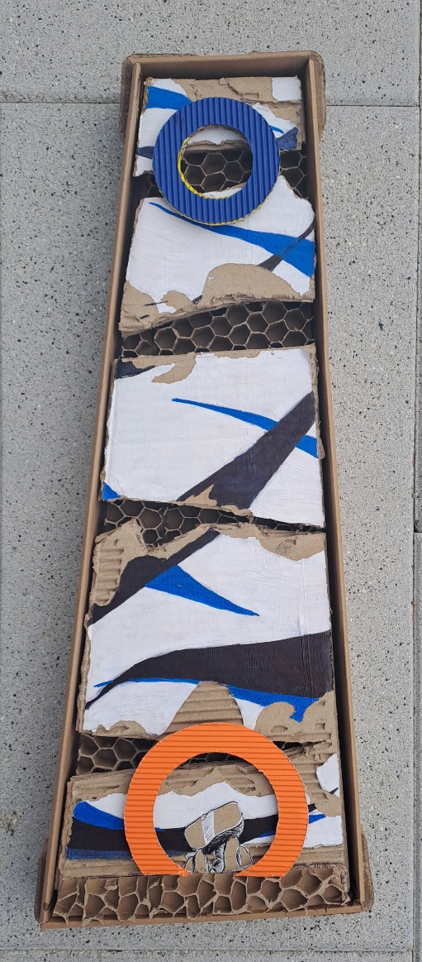
“Reincarnation”

Image List

- Unknown, Unheard, Unseen
2020 (101 x 101cm)
Pen, pencil, and acrylic marker recycled double corrugate cardboard.

- Somewhere Among the Clouds Above:
2022, (42 x 61.5cm)
Pen, pencil, and acrylic marker recycled double corrugate cardboard.

- Knotted Cascade:
2022, (33 x 52.5cm)
Pen, pencil, and acrylic marker on recycled double corrugate cardboard. This is known as the

- Butterflies of Vertigo
2022, (32 x 61 cm)
Pen, pencil, and acrylic marker on recycled double corrugate cardboard.

- Stencils of the Moon
2022, (53 x 74.5cm)
Pen, pencil, and acrylic marker on recycled double corrugate cardboard. Artwork of

- Beauty, It Curves
2022, (42 x 61.5cm)
Pen, pencil, and acrylic marker on recycled double corrugate cardboard.

- Embossed Aperture:
2022, (32 x 60.5cm)
Pen, pencil, and acrylic marker on recycled double corrugate cardboard.

- Reincarnation
2022 (21.5 x 36cm)
Pen, pencil, and acrylic marker on recycled double corrugate cardboard with honey comb corrugation

www.greghallahanart.com
